**CLASS B, Beginners**

**Γειά σας παιδιά. Αυτό είναι το 2ο φύλλο εργασίας. Να ξέρετε ότι το ίδιο ανεβάζω και στην e-class του ΠΣΔ .Κρατείστε σημειώσεις και απαντήσεις στο τετράδιό σας. Ωστόσο, για απορίες στείλτε μου στο** [iotaxi@sch.gr.](mailto:iotaxi@sch.gr.%20%20%20%20%20%20Να)  **Να προσέχετε.**

1. 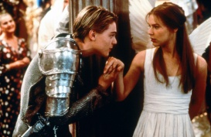**Read the text and answer the questions that follow.**

William Shakespeare

William Shakespeare was born in Stratford on April 23rd, 1564. His father, John Shakespeare, was an important man in the town – William didn’t come from a poor family.

When he was eighteen, William married Anne Hathaway in Stratford but he didn’t want to stay there. He wanted to be an actor and the best theatres were in London. So, in 1587, William went to London, where he worked as an actor in a theatre called The Rose.

He began to write plays for the actors. He wrote **Romeo and Juliet**, **Julius Caesar, Richard II, Antony and Cleopatra** ,Macbeth and many more. Everyone liked his plays, and he became famous.

When James I became king in 1603, Shakespeare worked for him, and performed his plays for the King and his friends. He also worked at the famous Globe Theatre. This play presented his last play, Henry VIII. There was a gun in this play, and the fire from the gun burned the theatre down.

In 1610, Shakespeare went back to Stratford. He wanted to live there with his family, but he died on April 23rd, 1610. He was only forty-six years old.

1. How old was Shakespeare when he got married?

__________________________________________

1. What was his wife’s name?

__________________________________________

1. Why did Shakespeare go to London?

__________________________________________

1. What was the name of the first theatre he worked in?

__________________________________________

1. What was he famous for?

__________________________________________

**B.Fill in the table with what happened in Shakespeare’s life in these years**.

|  |  |
| --- | --- |
| 1564 |  |
| 1582 |  |
| 1587 |  |
| 1603 |  |
| 1610 |  |

**C.COMPLETE THE SENTENCES WITH THE CORRECT FORM OF THE VERBS IN THE BOX. USE THE PRESENT SIMPLE AND THE PAST SIMPLE.**

be ⬥ die ⬥ visit ⬥ write ⬥ love ⬥ become ⬥ work ⬥ move ⬥ not live ⬥ be

Example: William Shakespeare __*was*__ born in Stratford on the 23th April 1564.

1. He __________________ on the same day, 23th April, fifty-two years later.
2. Over 500,000 tourists ___________________ Stratford every year.
3. Shakespeare _____________________ in Stratford all his life. He __________________ to London in 1585.
4. In London, he ____________________ as an actor and he ____________________ plays.
5. People __________________ Shakespeare’s plays and he _________________ a rich man.
6. Shakespeare’s plays ______________________ still very popular today.

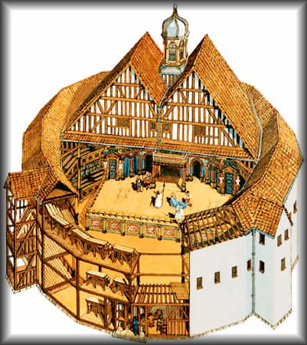**D.COMPLETE THE TEXT WITH THE CORRECT FORM OF PAST SIMPLE.**

The first Globe Theatre, Shakespeare’s theatre, __*burned*__ (*burn*) to the ground in 1613. Actors were performing the play **Henry VII** at the time. They were using a real cannon on the stage when suddenly a fire

**1.** _____________________ (*start*) in the roof. The fire

**2.** ___________________ (*move*) quickly through the wooden building and **3.**___________________ (*destroy*) it completely. A year later they

**4.** _________________ (*open*) the Globe theatre again.

**WATCH THE VIDEO BY THE BRITISH COUNCIL **

**MACBETH, by W.Shakespeare**

[**https://learnenglishteens.britishcouncil.org/uk-now/literature-uk/shakespeare-macbeth**](https://learnenglishteens.britishcouncil.org/uk-now/literature-uk/shakespeare-macbeth)

1. Macbeth has done a lot for Scotland in the recent battleΑρχή φόρμας True False

Τέλος φόρμας

2. The witches have bad news for MacbethΑρχή φόρμας True False

Τέλος φόρμας

3. Some of the witches' predictions come true immediately.Αρχή φόρμας True False

Τέλος φόρμας

4. Macbeth forgets about the prediction that he will become king.Αρχή φόρμας True False

Τέλος φόρμας

5. Lady Macbeth doesn't want Macbeth to be king.Αρχή φόρμας True False

Τέλος φόρμας

6. It's Lady Macbeth's idea to murder King Duncan.Αρχή φόρμας True False

Τέλος φόρμας

7. Macbeth murders King Duncan while his guards are asleep.Αρχή φόρμας True False

Τέλος φόρμας

8. Duncan's son becomes the new King of Scotland.Αρχή φόρμας True False

Τέλος φόρμας

9. The witches tell Macbeth he will be safe until a forest comes to his castle Αρχή φόρμαςTrue False

Τέλος φόρμας

10. Lady Macbeth goes mad with guilt and commits suicide. Αρχή φόρμαςTrue False

Τέλος φόρμας

11. Macbeth's enemies, the English army, take branches from the trees for protection. Αρχή φόρμαςTrue False

Τέλος φόρμας

12. The witches lied to Macbeth about his death. Αρχή φόρμαςTrue False

Τέλος φόρμας

*Check your understanding: 1.True 2.False 3.True 4.False 5. False 6.True 7.True 8.False 9.True 10.True 11. True 12. False.*